**EXPERIMENT-6**

**Submitted by:**Ajay Kumar Tyagi  
500067403  
R171218008  
CSE-DevOps 2018-2022

**Aim:** To link one container with another container while launching and monitor the container.

**Procedure:**

**1)** First launch one container using command **docker run**. Now while launching another container use option **--link <container-1-name:alias>**. For example, in the below screenshot to link dockeros-2 with dockeros-1, **--link dockeros-1:myos**.  
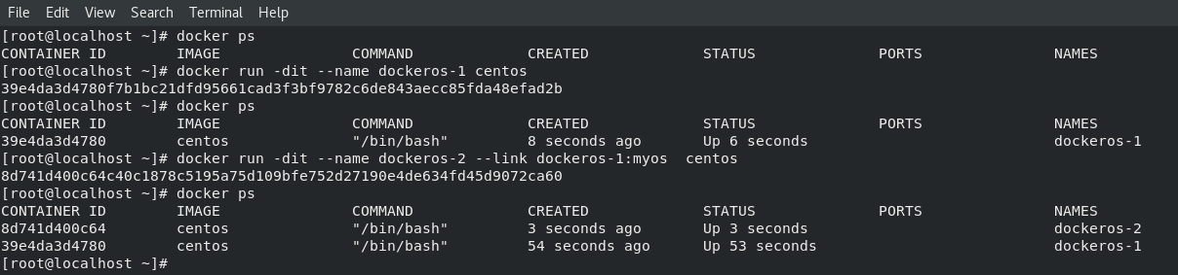

**2)** Now go inside the second container using command **docker exec -it <container-name> bash**. Once inside the container use **ping** command to ping to first container using its alias name.  
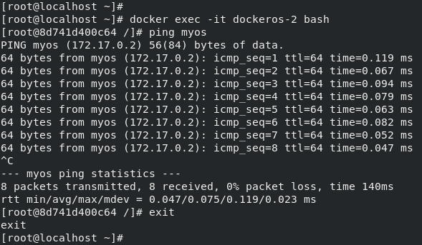

**3)** Now launch another container using **docker run** command. Now run **docker stats** command to see the stats of running container and monitor them.

